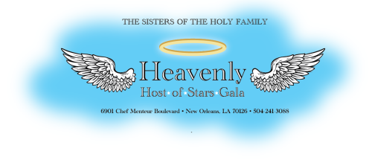

June 6, 2017

Dear «First_Name»,

For 175 years, the Sisters of the Holy Family have been the faces of love, mercy, and compassion to the most vulnerable in our community. Since their founding in 1842 by the Venerable Henriette Delille, a free woman of color, the Sisters have sacrificed and given a life-time of service by providing education, healthcare, low-income housing for senior citizens, prison ministry, social and pastoral care to all families, with special attention to the poor and marginalized.

In celebration and support of the Sisters of the Holy Family’s 175 years of ministry and to provide for the needs of the elderly Sisters, we are asking you to join us with your generous support of a musical and culinary extravaganza, “Heavenly Hosts of Stars,” Gala at the Hyatt Regency Hotel, New Orleans on Sunday, August 20, 2017. The legendary Ellis Marsalis, the patriarch of the musical Marsalis family, will perform at the benefit along with Davell Crawford, Wanda Rouzan, Sharon Martin and other great artists. In addition to extraordinary musical talent, we will have a taste of the delectable cuisine for which New Orleans is famous.

We are counting on your generosity in this dodransbicentennial year to ensure the success of this most worthy event. We invite you to support the Sisters by completing and returning the enclosed sponsorship form by June 23, 2017. Commitment by this date will ensure that your sponsorship will be acknowledged in the program and in the promotional materials.

Come and join us as we continue to celebrate 175 years of dedicated services of the Sisters of the Holy Family.

Sincerely,

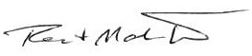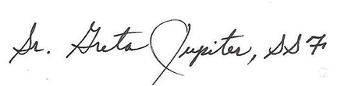
Rod & Madeline West Sr. M. Greta Jupiter, S.S.F.
Honorary Chair Couple Congregational Leader

P.S. Please visit www.sistersoftheholyfamily.com for more information on the Sisters of the Holy Family and their 175th Anniversary.

~∙~
Rod & Madeline West
Honorary Chair Couple

Tracie Boutte
Gala Chair

Gail Armant ∙ Tracie Boutte ∙ Sr. Leona Bruner, S.S.F. ∙ Gretta ∙Burns ∙ Sr. Alicia Costa, S.S.F. ∙
Willard Dumas ∙ Connie Fitch ∙ Kim Hypolite ∙ Sr. Greta Jupiter, S.S.F. ∙ Clarice Kirkland ∙ Marianne Koehl ∙
Wayne Lemelle ∙ Rhesa McDonald ∙ Demetric Mercadel ∙ Jane Nalty ∙ Sandra Rhodes-Duncan∙
Alexis Robinson ∙ Mark Romig Marcia St. Martin ∙ Michael O. Smith ∙ Gordon Stevens ∙ Carroll Suggs ∙
Janice C. Taylor ∙ Diane Tillman ∙ Madeline West
Gala Committee Members

